**Setting Up Application**

**Environment**

**SendGrid Account creation**

|  |  |
| --- | --- |
| Date | 10 Nov 2022 |
| Team ID | PNT2022TMID11845 |
| Project Name | Smart Fashion Recommender Application |

**Sendgrid Home Page:**

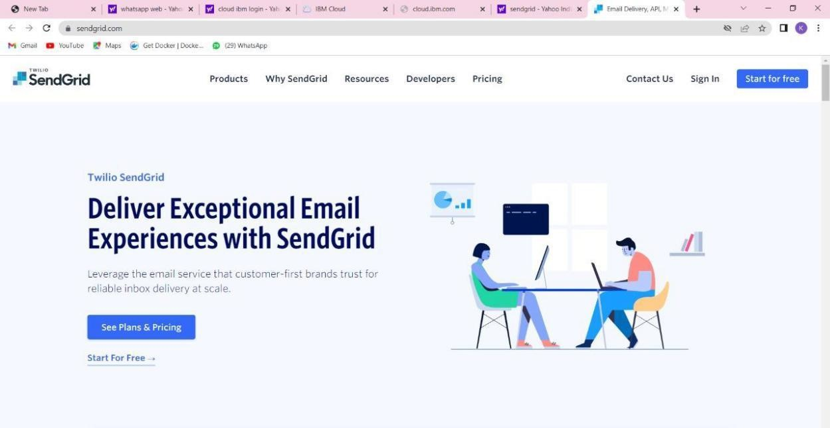

**Sendgrid login Page:**

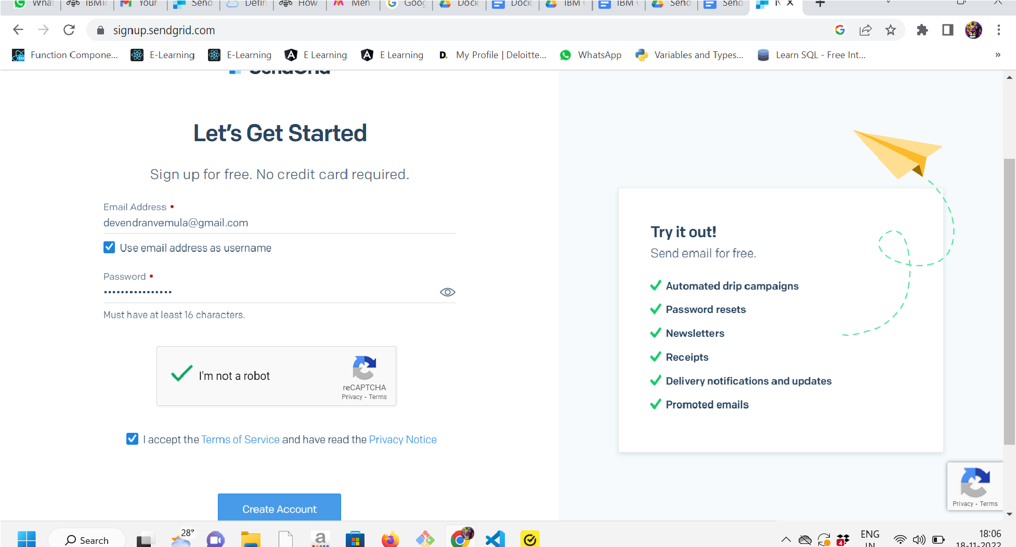

**Sendgrid successfully created:**